


ALL SAINTS’ Safeguarding Team are committed to keeping you safe and are always happy to help and talk if you need to.
Do you need to talk?
Are you worried about something or someone? Do you feel unsafe? Are you worried about somebody else’s safety?
You can always talk to your class teacher, an adult in your class or any of these adults in school. We are ready to listen to you.
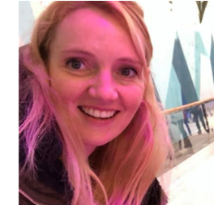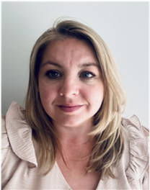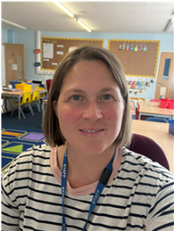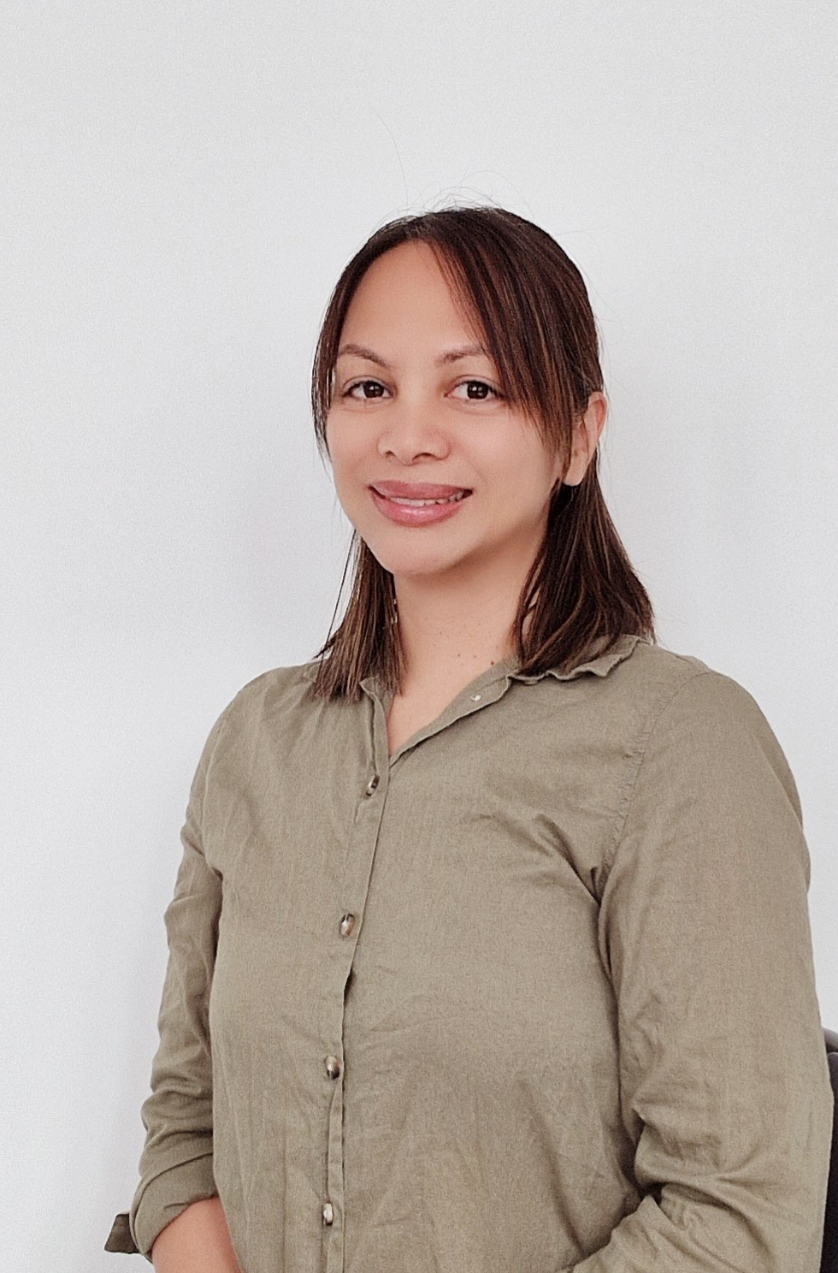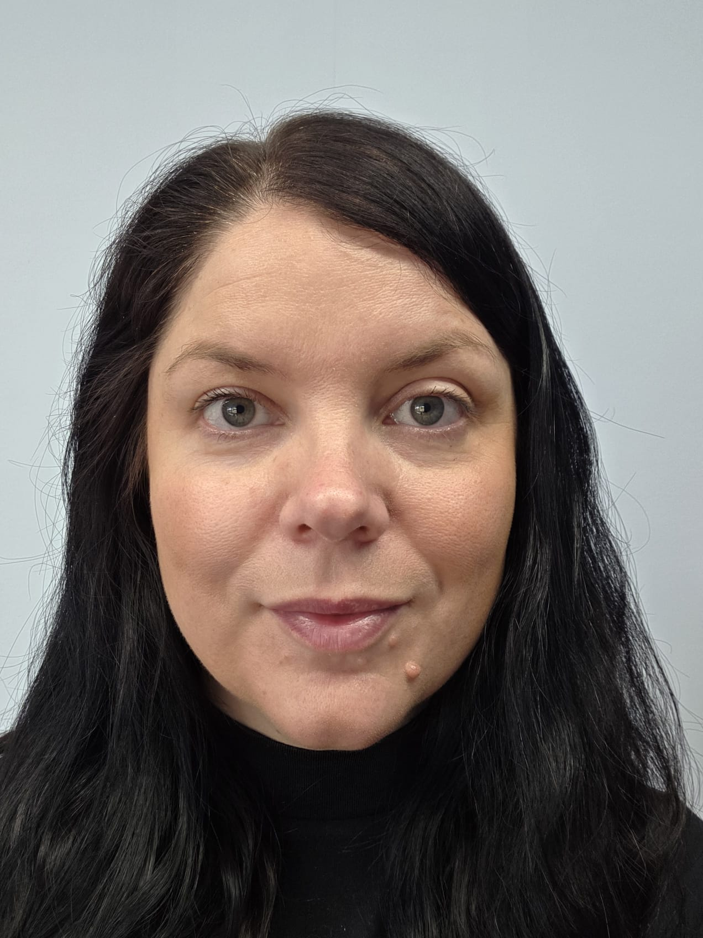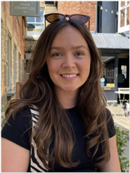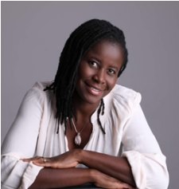
Miss K Hammond Mrs N Mcmanus Mrs L Oakley Mrs M Howie Mrs K Conway Miss C Hewson Mrs D Nartey
DSL ADSL ADSL ADSL ADSL SENDco ONLINE SAFETY GOVERNOR



w .

